**Editing Note: Michael is working on revisions. This entry has been read by me and Isabel (Wunsch?)**

**TATLIN, Vladimir (1885-1953)**

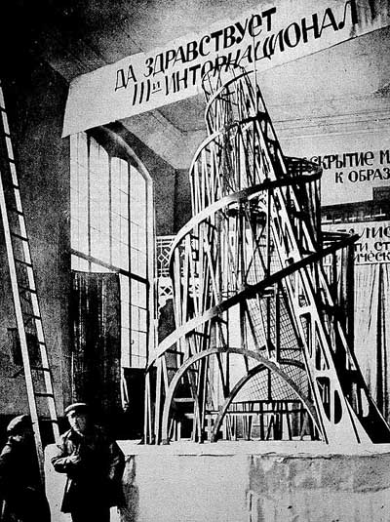The Russian artist and architect Vladimir Tatlin was one of the central figures in the [Russian avant-garde](http://en.wikipedia.org/wiki/Russian_avant-garde) in the years surrounding the Bolshevik Revolution of 1917. The progenitor and major theorist of RUSSIAN CONSTRUCTIVISM, he was instrumental in developing the machine aesthetic that became a central component of Modernist architecture and design. He is best known for his unrealised, but visionary design for a giant tower, the Monument to the Third International, which exemplified Constructivist theory and practice.

Tatlin was born in Moscow, the son of a railway engineer and a poet, and raised in Kharkov, Ukraine. After working as a merchant seaman, he began his artistic career as an icon painter. Tatlin was educated at the Moscow Academy of Fine Arts from 1902-4. In 1913 he visited Paris - the capital of the art world - and encountered the CUBISM of PABLO PICASSO, whose sculptural experiments inspired Tatlin to create his own ‘painterly reliefs’, abstract relief sculptures made from industrial materials.

Vladimir Tatlin, model of [The Monument to the Third International](http://en.wikipedia.org/wiki/The_Monument_to_the_Third_International), 1920

Tatlin was at the forefront of a group of artists inspired by the modern world of machinery and mass production. Coalescing to form the avant-garde Constructivist movement, these practitioners saw themselves as artist-engineers whose task was to construct the art and architecture of the new society created by the Bolshevik Revolution and by the technology that promised to transform Russia into an industrial power. Applying engineering techniques to their work, the Constructivists developed an aesthetic that was inspired by machines and adapted to the needs of modernity.

Constructivism briefly enjoyed the support of the Soviet state, which recognised the propaganda value of the striking architecture, graphics and textiles being produced. In 1919 the Department of Fine Arts commissioned Tatlin to design the Monument to the Third International (a Bolshevik organisation for coordinating Communist activities around the world). Envisaged as an immense tower in iron, glass and steel, the monument would have been the tallest structure in the world (396m). Astronomical costs and waning political support prevented it from being built and it was only ever realised as a 6.7m high model that was exhibited at the VIII Congress of the Soviets in December 1920. In conception, however, the tower was a triumph of the machine aesthetic and a captivating monument to the ideals of the Revolution.

Vladimir Tatlin, model of [The Monument to the Third International](http://en.wikipedia.org/wiki/The_Monument_to_the_Third_International), 1920

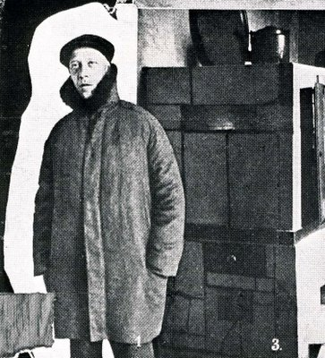Tatlin saw the designer as an anonymous worker whose task was to serve society. He became increasingly concerned with mass production and standardisation as means by which functional products could be made available to the masses. To this end, he established the Department of Material Culture at the Petrograd Museum of Artistic Culture and from 1927 taught at VKhUTEMAS, a Russian counterpart to the BAUHAUS. He designed a workers’ boiler-suit and an economical stove intended for mass production, as well as ceramics and furniture, but these ventures were only partly successful.

In his later years Tatlin became preoccupied with the concept of unpowered flight and began working on a glider called Letatlin(a compound of his name and ‘letat’, the Russian verb ‘to fly’), whichresembled a giant insect. Despite extensive research, the glider never flew. After 1933 Tatlin devoted much of his energy to figurative painting and stage design. He died in relative obscurity in 1953.

Tatlin wearing a coat of his own design, standing in front of a stove of his own design, 1919.

**References and further reading**

Harten, J. (1993) *Vladimir Tatlin: Leben, Werk, Wirkung*, Kšln: DuMont. (A collection of essays on Tatlin’s life and work, with text in German and Russian).

Milner, J. (1983) *Vladimir Tatlin and the Russian Avant-Garde.* New Haven: Yale University Press. (Based on extensive research in the former Soviet Union, this volume places Tatlin’s work in a Russian context, examining the cultural and political forces that shaped it).

Lynton, N. (2009) *Tatlin's Tower: monument to revolution*. New Haven: Yale University Press. (A discussion of Tatlin's output, including a detailed account of the conception of his Monument to the Third International).

Nakov, A.B. (1973) *Tatlin's Dream: Russian Suprematist and Constructivist Art, 1910-1923*. London: Fischer Fine Art. (Catalogue of an exhibition held in 1973-4 at Fischer Fine Art Limited, London).

Zhadova, L.A. (1988) *Tatlin*, New York: Rizzoli. (A comprehensive monograph illustrated with over 400 images. The volume contains Tatlin’s writings in translation and a list of works).

Michael Johnson, University of Newcastle

Source URL for images

Figure 1 <http://upload.wikimedia.org/wikipedia/commons/f/ff/Tatlin%27s_Tower_maket_1919_year.jpg>

Figure 2

http://counterlightsrantsandblather1.blogspot.ca/2009/04/working-stiff-in-art-tatlins-tower.html